Church Walk Primary School DT Scheme of Work
Springfield Cycle Year 5 / 6 Cycle A |  | Year 5 Year 6 |  | Key Assessment Criteria
 | Autumn | Spring | Summer
Focus | Making stamps  Victorian Room (model, textiles, electrical systems)  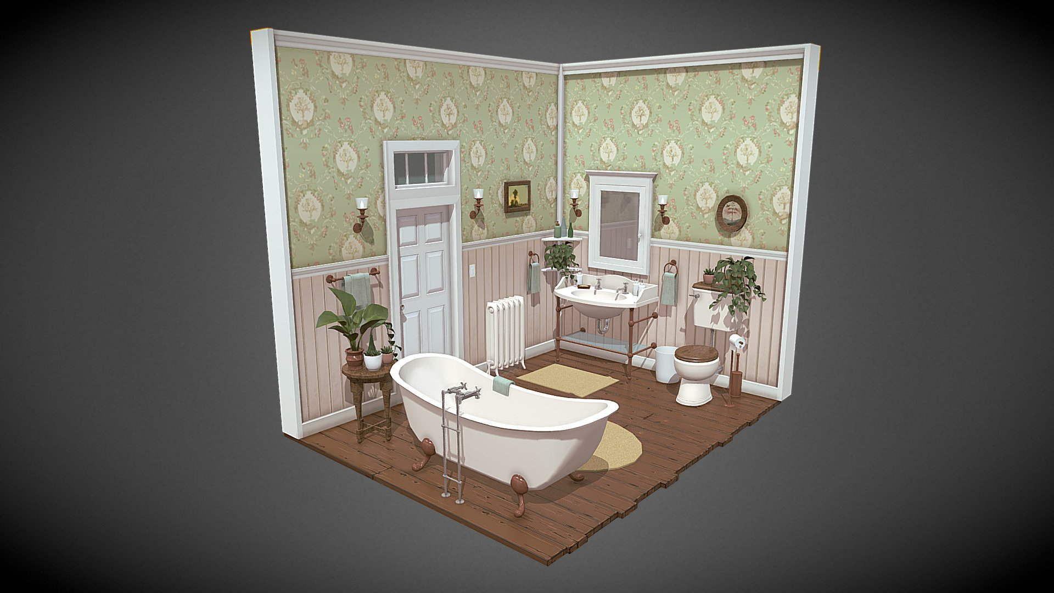 | Making soap and packaging  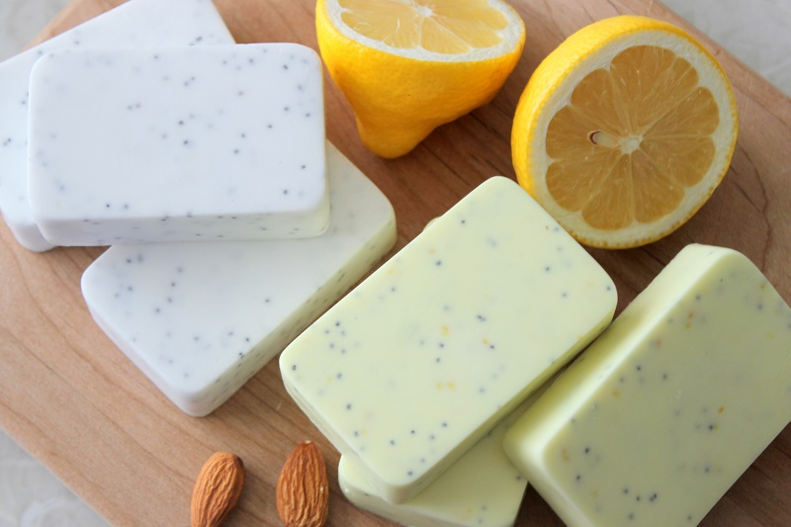  Fairtrade cooking | 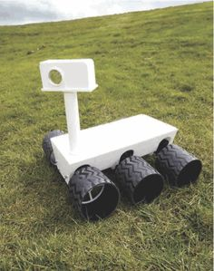  Levers and linkage/ mechanisms : Making moon buggies | - I can come up with a range of ideas after collecting information from different sources  - I can produce a detailed, step-by-step plan  - I can suggest alternative plans;outlining the positive features and draw backs  - I can explain how a produt will appeal to a specific audience  - I can evaluate appearance and function against original criteria  - I can use a range of tools and equipment competently  - I can make a prototype before I make a final version  - I can show that I can be both hygenic and safe in the kitchen  - I can use market research to inform my plans and ideas  - I can follow and refine my plans  - I can justify my plans in a convincing way  - I can show that I consider culture and society in my plans and designs  - I can show that I can test and evaluate my products  - I can explain how products should be stored and give reasons  - I can work within a budget  - I can evaluate my product against clear criteria
Resources | Recycled materials, paper, coloured card, wood, dowel rod, basic hand tools for cutting wood and making holes, |  | Examples of variety of controllable toy vehicles,kits, wire, crocodile leads,switches, aluminium foil, batteries and holders  Motors, motor mounting clips  Pulleys, elastic bands  Square section wood, dowel rods, card triangles, glue, plastic tubing  Materials for finishing  Wire strippers
Curriculum links | History- the Victorians  Maths- measuring  Literacy- notes, labels, explanations  Science- electrical | Maths- measuring (weighing, using different scales) | History- the Space Race  Maths- measuring  Literacy- notes, labels, explanations
Skills | Generate ideas  Plan what to do next  Select appropriate tools, materials, components  Explain choices  Produce annotated diagrams  Measure, mark out, cut and assemble  Use ICT for researching and designing  Techniques for reinforcing and strengthening materials  Use bench hook / G-cramp hacksaw safely | Research and design for a specific purpose- investigation and analysis  Developing design criteria  Choosing appropiate ingredients (additions) and utensils  Designing packaging according to criteria  Making and evaluating prototypes  Evaluating finished products against design criteria | Mark out, cut and join  Techniques for reinforcing and strengthening  Select appropriate tools, materials, components  Methods of construction (variety)  Design for a specific purpose  Show designs and follow them  Modify designs

